**Crime Investigation with Cybernetic Protector**

Abstract

Cybernetic Protectors is to provide a secure way of communication and transferring evidences in Secret Intelligence Agency of defence system which always uses undercover agents to solve complex cases and dismantle criminal organizations. We are conceptualizing this software as a solution so that Secret Intelligence Agencies and their agent can communicate through this Software for the exchange of evidences in a secure way, and maintain the details of main officer. The Cybernetics Protector software is concerned with the security of the country and thus proper care has to be taken that confidential data from within the database is not leaked out. Every country requires a Secret Agency who undertakes cases which are a threat to the national security. These agencies operate with the help of undercover agents who help solve these cases. Since these cases deal with the nation’s security, the communication and data transfer between the agents and higher authorities need to be protected.

PROBLEM DEFINITION

The main objective of Crime Investigation with Cybernetic Protectors is to provide a secure way of communication and transferring evidences in Secret Intelligence Agency of defence system which has always uses undercover agents to solve complex cases and dismantle criminal organizations. We are conceptualizing this software as a solution so that Secret Intelligence Agencies and their agents can communicate through this Software for the exchange of evidences in a secure way and maintain the details of Defence Minister.

Figure 1

Explains overall functionality of the system along with different set of users involved. In the information systems development field, requirements form the foundation for the rest of the software development process. Since building a high-quality requirements specification is essential to ensure that the product satisfies the users

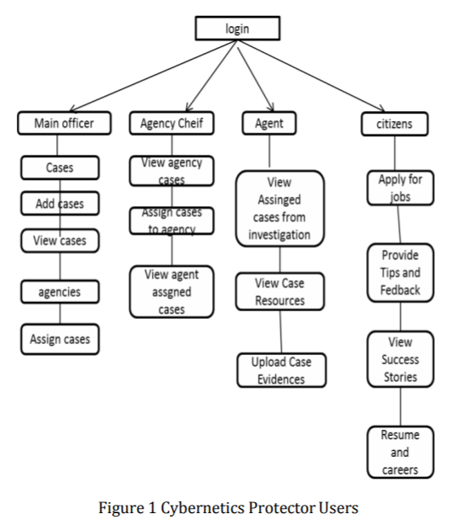

The development of this new system contains the following activities, which try to automate the entire process keeping in the view of database integration approach. This system maintains user’s personal, address, and contact details. User friendliness is provided in the application with various controls provided by system rich user interface. This system makes the overall project management much easier and flexible. Our project crime investigation with cybernetic protector basically consist of five modules are as follows

1. Defence Ministry
2. ii. Secret Intelligence agency chief
3. Undercover Agent
4. Security and Authentication Module
5. Citizen